GET
FILE='C:\Users\eb0099a\Desktop\SeepsProjectArcMap\spss\Seeps.sav'.
DATASET NAME DataSet1 WINDOW=FRONT.
FACTOR
/VARIABLES AWC CLAY OM PERM THICK LL KFFACT HYGRP DRAIN IFHYDRIC AFLDFREQ
/MISSING LISTWISE
/ANALYSIS AWC CLAY OM PERM THICK LL KFFACT HYGRP DRAIN IFHYDRIC AFLDFREQ
/PRINT INITIAL EXTRACTION
/PLOT EIGEN
/CRITERIA FACTORS(6) ITERATE(25)
/EXTRACTION PC
/ROTATION NOROTATE
/SAVE REG(ALL)
/METHOD=CORRELATION.

- - - - - - - - - - - - - - - - - - - - - - - - F A C T O R A N A L Y S I S - - - - - - - - - - - - - - - - - - - - - - - -

Factor Analysis

[DataSet1] C:\Users\eb0099a\Desktop\SeepsProjectArcMap\spss\Seeps.sav

Correlation Matrixª

a. This matrix is not positive definite.

Communalities
 | Initial | Extraction
AWC | 1.000 | 1.000
CLAY | 1.000 | 1.000
OM | 1.000 | 1.000
PERM | 1.000 | 1.000
THICK | 1.000 | 1.000
LL | 1.000 | 1.000
KFFACT | 1.000 | 1.000
HYGRP | 1.000 | 1.000
DRAIN | 1.000 | 1.000
IFHYDRIC | 1.000 | 1.000
AFLDFREQ | 1.000 | 1.000

Extraction Method: Principal Component Analysis.

Total Variance Explained
Component | Initial Eigenvalues |  |  | Extraction Sums of Squared Loadings
Component | Total | % of Variance | Cumulative % | Total | % of Variance | Cumulative %
1 | 6.016 | 54.689 | 54.689 | 6.016 | 54.689 | 54.689
2 | 3.923 | 35.659 | 90.349 | 3.923 | 35.659 | 90.349
3 | .802 | 7.295 | 97.644 | .802 | 7.295 | 97.644
4 | .160 | 1.457 | 99.101 | .160 | 1.457 | 99.101
5 | .099 | .899 | 100.000 | .099 | .899 | 100.000
6 | 2.873E-15 | 2.612E-14 | 100.000 | 2.873E-15 | 2.612E-14 | 100.000
7 | 1.807E-15 | 1.642E-14 | 100.000
8 | -2.151E-16 | -1.955E-15 | 100.000
9 | -2.060E-15 | -1.873E-14 | 100.000
10 | -2.524E-15 | -2.294E-14 | 100.000
11 | -3.343E-15 | -3.039E-14 | 100.000

Extraction Method: Principal Component Analysis.

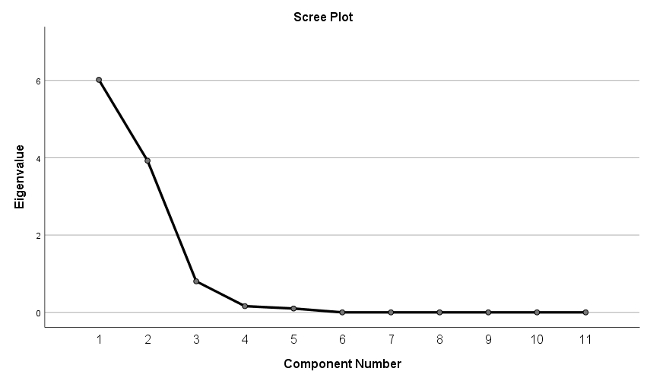

Component Matrixª
 | Component
 | 1 | 2 | 3 | 4 | 5 | 6
AWC | .281 | .934 | .105 | .151 | .126 | .000
CLAY | -.926 | .318 | .151 | .024 | .138 | .000
OM | .864 | .441 | -.179 | -.164 | .027 | .000
PERM | .532 | -.633 | -.536 | .168 | .029 | .000
THICK | .314 | -.927 | .043 | .073 | .188 | .000
LL | -.806 | .590 | .011 | .046 | .015 | .000
KFFACT | .430 | -.791 | .430 | -.065 | -.024 | .000
HYGRP | .898 | .005 | .436 | .007 | .061 | .000
DRAIN | .912 | .356 | .150 | .109 | -.088 | .000
IFHYDRIC | .880 | .447 | .022 | .147 | -.057 | .000
AFLDFREQ | -.840 | -.442 | .223 | .192 | -.109 | .000

Extraction Method: Principal Component Analysis.ª
a. 6 components extracted.

FACTOR
/VARIABLES AWC CLAY KFFACT OM PERM THICK HYGRP DRAIN LL IFHYDRIC AFLDFREQ
/MISSING LISTWISE
/ANALYSIS AWC CLAY KFFACT OM PERM THICK HYGRP DRAIN LL IFHYDRIC AFLDFREQ
/PRINT INITIAL EXTRACTION FSCORE
/PLOT EIGEN
/CRITERIA FACTORS(6) ITERATE(25)
/EXTRACTION PC
/ROTATION NOROTATE
/SAVE REG(ALL)
/METHOD=CORRELATION.

Factor Analysis

Correlation Matrixª

a. This matrix is not positive definite.

Communalities
 | Initial | Extraction
AWC | 1.000 | 1.000
CLAY | 1.000 | 1.000
KFFACT | 1.000 | 1.000
OM | 1.000 | 1.000
PERM | 1.000 | 1.000
THICK | 1.000 | 1.000
HYGRP | 1.000 | 1.000
DRAIN | 1.000 | 1.000
LL | 1.000 | 1.000
IFHYDRIC | 1.000 | 1.000
AFLDFREQ | 1.000 | 1.000

Extraction Method: Principal Component Analysis.

Total Variance Explained
Component | Initial Eigenvalues |  |  | Extraction Sums of Squared Loadings
Component | Total | % of Variance | Cumulative % | Total | % of Variance | Cumulative %
1 | 6.016 | 54.689 | 54.689 | 6.016 | 54.689 | 54.689
2 | 3.923 | 35.659 | 90.349 | 3.923 | 35.659 | 90.349
3 | .802 | 7.295 | 97.644 | .802 | 7.295 | 97.644
4 | .160 | 1.457 | 99.101 | .160 | 1.457 | 99.101
5 | .099 | .899 | 100.000 | .099 | .899 | 100.000
6 | 3.123E-15 | 2.839E-14 | 100.000 | 3.123E-15 | 2.839E-14 | 100.000
7 | 2.415E-15 | 2.195E-14 | 100.000
8 | 7.847E-16 | 7.133E-15 | 100.000
9 | -1.536E-15 | -1.396E-14 | 100.000
10 | -2.449E-15 | -2.226E-14 | 100.000
11 | -3.696E-15 | -3.360E-14 | 100.000

Extraction Method: Principal Component Analysis.

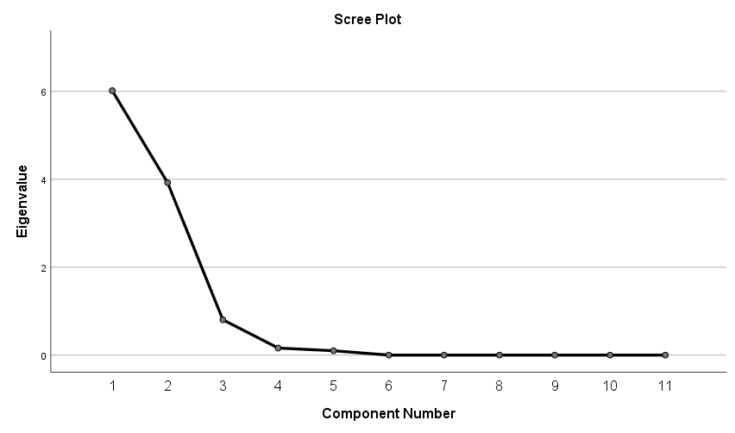

Component Matrixª
 | Component
 | 1 | 2 | 3 | 4 | 5 | 6
AWC | .281 | .934 | .105 | .151 | .126 | .000
CLAY | -.926 | .318 | .151 | .024 | .138 | .000
KFFACT | .430 | -.791 | .430 | -.065 | -.024 | .000
OM | .864 | .441 | -.179 | -.164 | .027 | .000
PERM | .532 | -.633 | -.536 | .168 | .029 | .000
THICK | .314 | -.927 | .043 | .073 | .188 | .000
HYGRP | .898 | .005 | .436 | .007 | .061 | .000
DRAIN | .912 | .356 | .150 | .109 | -.088 | .000
LL | -.806 | .590 | .011 | .046 | .015 | .000
IFHYDRIC | .880 | .447 | .022 | .147 | -.057 | .000
AFLDFREQ | -.840 | -.442 | .223 | .192 | -.109 | .000

Extraction Method: Principal Component Analysis.ª
a. 6 components extracted.

Component Score Coefficient Matrix
 | Component
 | 1 | 2 | 3 | 4 | 5 | 6
AWC | .047 | .238 | .131 | .940 | 1.270 | -8912231.531
CLAY | -.154 | .081 | .189 | .147 | 1.393 | 353945.925
KFFACT | .072 | -.202 | .536 | -.406 | -.239 | -3984887.698
OM | .144 | .112 | -.223 | -1.021 | .276 | 4923653.273
PERM | .088 | -.161 | -.667 | 1.049 | .290 | -751072.465
THICK | .052 | -.236 | .054 | .453 | 1.901 | 6187442.557
HYGRP | .149 | .001 | .544 | .046 | .618 | 3572258.986
DRAIN | .152 | .091 | .187 | .680 | -.886 | 4980143.904
LL | -.134 | .150 | .014 | .285 | .149 | 10955490.975
IFHYDRIC | .146 | .114 | .028 | .915 | -.574 | 1292094.198
AFLDFREQ | -.140 | -.113 | .277 | 1.200 | -1.101 | 1552218.368

Extraction Method: Principal Component Analysis.
Component Scores.

Component Score Covariance Matrix
Component | 1 | 2 | 3 | 4 | 5 | 6
1 | 1.000 | .000 | .000 | .000 | .000 | .000
2 | .000 | 1.000 | .000 | .000 | .000 | .000
3 | .000 | .000 | 1.000 | .000 | .000 | .000
4 | .000 | .000 | .000 | 1.000 | .000 | .000
5 | .000 | .000 | .000 | .000 | 1.000 | .000
6 | .000 | .000 | .000 | .000 | .000 | 1.000

Extraction Method: Principal Component Analysis.
Component Scores.

